**Minor Project Report**

**on**

ONLINE JOB PORTAL

**In partial fulfillment for the award of the degree**

**Of**

**BACHELOR OF COMPUTER APPLICATION**

**[B.C.A]**

**Year 2023-2024**

**SUBMITTED BY: GUIDED BY:**

**Gola Jinal Prof. Bipin Jadav**

**BCA-5th SEMESTER**

**Submitted to:**



**SHRI SHAMBHUBHAI V. PATEL COLLEGE OF**

**COMPUTER SCIENCE & BUSINESSMANAGEMENT**

Affiliated to

**Veer Narmad South Gujarat University**

**CERTIFICATE**

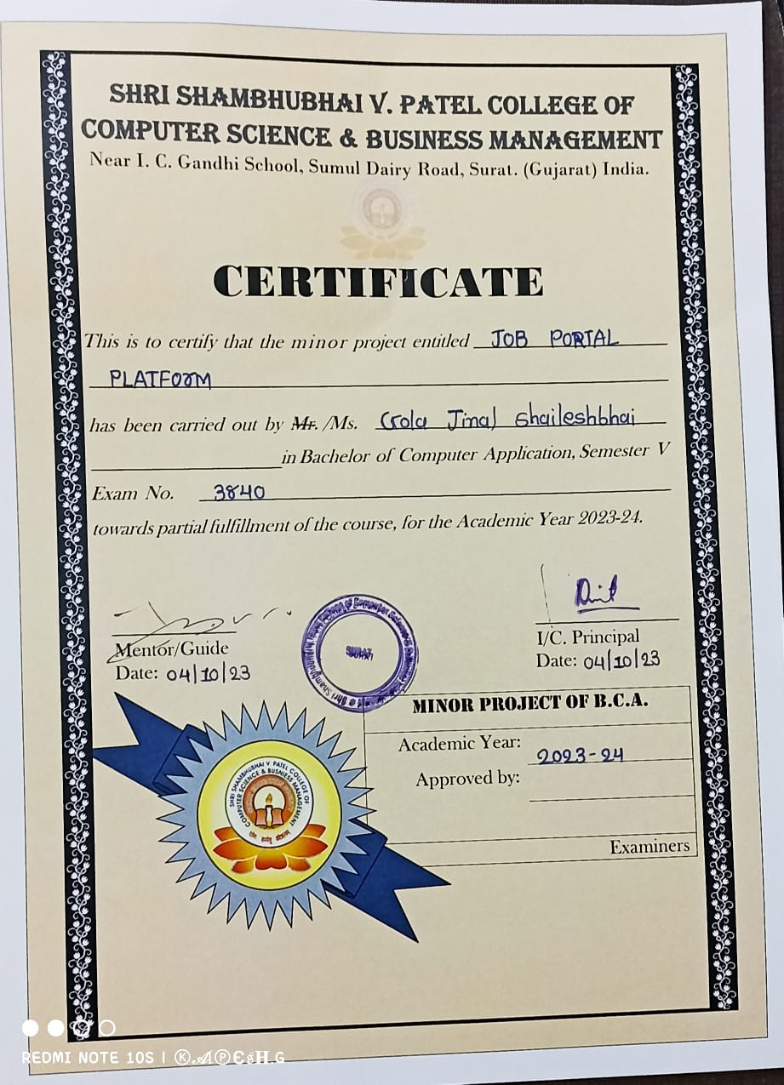

**Acknowledgement**

* My Self Ms. Jinal Gola have opportunity to express my knowledge.

I would like to express my deep and sincere gratitude to our Project Mentor Prof. Bipin Jadav and Our HOD Prof. Riddhi Vyas, for giving me the opportunity to do this project and provide valuable guidance throughout this project. Your vision, sincerity and motivation have deeply inspired me. He has taught us the methodology to carry out the project and to present the project work as clearly as possible. It was a great privilege and honour to work and study under him guidance. I am extremely grateful for what he has offered me. I would also like to thank him for his friendship, empathy, and great sense of humor.

* I would like to take opportunity to thank my college,Shri Shambhubhai V.patel college of Computer Science & Business Management,Surat.
* I am very thankful and fortunate enough to get support and guidance from all Teaching staffs of Bachelores of Computer Application Department which helped us in successfully completing our project work. Also, we would like to extend our sincere regards to all the non-teaching staff of Bachelores of Computer Application Department for their timely support.

Thanking You

**YOUR FAITHFULLY ,**

Jinal Gola.

**Index**

|  |  |
| --- | --- |
| **Chapters** | Page No. |
| 1.Introduction  1.1 Objective  1.2 Core Components  1.3 Software /Hardware Requirements  1.4 Technology Used  2.Requirement Determination & Analysis  2.1 Requirement Determination  2.2 Users of System  3.Sytem Design  3.1 ER Diagram  3.2 Sytem Flowchart  3.3 Data Flow Diagram  3.3 Data Tables  4. Screenshots  5. References | 5 |

**MINOR PROJECT**

1. **INTRODUCTION**

* **What is a job portal?**

A job portal is a website where people who need jobs can find jobs and companies looking for job seekers can find the perfect employees. It serves as a medium where job seekers can create profiles, upload resumes, and search for job openings across various categories and locations.

* **Project Profile :**

|  |  |
| --- | --- |
| **Project Type:** | Website |
| **Project Title** | Job Poratl (Job Dekho) |
| **Front End** | HTML5 ,CSS ,Javascript ,Bootstrap |
| **Back End** | PHP ,MySQL |
| **Internal Guide** | Asst. Prof. Bipin Jadav |
| **Submitted To** | Shri Shambhu bhai V. Patel College of Computer Science & Business Management, Surat. |
| **Submitted By** | Ms. Jinal Gola |

* 1. **Objective**
  + The main objective of Job Portal System is to manage the Jobseeker (Employee) and Company (Employer) Registration ,Search job and Details of their jobs.
  + It manage all information about Post a specific job and you can Search

the specific job.

* + Provide a platform for company ( Employer) to Post Job Listing.
  + Connect the Employees with suitable opportunity.
  + Our main motive is provide a Best Job to each Employee.
  1. **Core Component**
  + Manage Jobs
  + Manage Applied Jobs
  + Manage Jobseeker
  + Manage Search Job
  + Manage Post Jobs
  + Download Resume

**1.3 Software /Hardware Requirements**

* **Hardware Requirements**

|  |  |
| --- | --- |
| **Processor:** | Processor Rizen (R)5 CPU |
| **Memory:** | 4 GB |
| **Hard Disk:** | 256 GB |

* **Software Requirements**

|  |  |
| --- | --- |
| **Operating System:** | Windows 11 |
| **Front End:** | Visual Studio |
| **Back End:** | MySQL |
| **Scripting Language:** | Javascript ,css ,Ajax |

**1.4 Technology Used**

* **PHP :**
  + PHP is a recursive acronym for "PHP: Hypertext Preprocessor".
  + PHP is a server side scripting language that is embedded in HTML. It is used to manage dynamic content, databases, session tracking, even build entire e-commerce sites.
  + It is integrated with a number of popular databases, including MySQL, PostgreSQL, Oracle, Sybase, Informix, and Microsoft SQL Server.
  + PHP supports a large number of major protocols such as POP3, IMAP, and LDAP. PHP4 added support for Java and distributed object architectures (COM and CORBA), making n-tier development a possibility for the first time.
  + PHP Syntax is similar to C and Perl.
  + PHP performs system functions, i.e. from files on a system it can create, open, read, write, and close them.
  + PHP can handle forms, i.e. gather data from files, save data to a file, through email you can send data, return data to the user.
  + You add, delete, modify elements within your database through PHP.
  + Access cookies variables and set cookies.
  + Using PHP, you can restrict users to access some pages of your website.
  + It can encrypt data.
* **XAMPP :**
  + XAMPP is one of the widely used cross-platform web servers, which helps developers to create and test their programs on a local webserver.
  + It was developed by the **Apache Friends**, and its native source code can be revised or modified by the audience.
  + It consists of **Apache HTTP Server, MariaDB, and interpreter** for the different programming languages like PHP and Perl.
  + It is available in 11 languages and supported by different platforms such as the IA-32 package of Windows & x64 package of macOS and Linux.
  + XAMPP is an abbreviation where **X stands for Cross-Platform, A stands for Apache, M stands for MYSQl, and the Ps stand for PHP and Perl**, respectively. It is an open-source package of web solutions that includes Apache distribution for many servers and command-line executables along with modules such as Apache server, MariaDB , PHP, and Perl.
* **MySQL :**
  + MySQL is a very powerful program in its own right. It handles a large subset of the functionality of the most expensive and powerful database packages.
  + MySQL uses a standard form of the well-known SQL data language.
  + MySQL works on many operating systems and with many languages including PHP, PERL, C, C++, JAVA, etc.
  + MySQL works very quickly and works well even with large data sets.
  + MySQL is very friendly to PHP, the most appreciated language for web development.
  + MySQL supports large databases, up to 50 million rows or more in a table. The default file size limit for a table is 4GB, but you can increase this (if your operating system can handle it) to a theoretical limit of 8 million terabytes (TB).
  + MySQL is customizable. The open-source GPL license allows programmers to modify the MySQL software to fit their own specific environments.
* **JavaScript :**
  + **JavaScript** is a lightweight, interpreted **programming** language.
  + It is designed for creating network-centric applications.
  + It is complimentary to and integrated with Java.
  + **JavaScript** is very easy to implement because it is integrated with HTML. It is open and cross-platform.

**2. REQUIREMENT DETERMINATION & ANALYSIS**

**2.1 Requirement Determination**

* Admin

In this module Admin will add all the attributes, city, state, country and update and delete information about the job provider or job seeker he/she can also search for the job seeker and he/she can send mail to offer the job to job seeker and he/she can also see the jobs add by the job provider.

* Job Seeker

In this module Job Seeker register him/her self and upload his resume and fill the profile give by admin and after login he will search for the job on various conditions and he/she can change his profiles and resume and he can apply for the jobs based on various conditions. He/She can see the response of the company and he/she can call the company person for the interview.

* Job provider

In this module Job Provider register him/her self and his/her company and after login he/she will add new job and he/she can offer the job to job seeker according to the job .He /She can also Add ,Remove ,Edit the jobs .Job Provider also manage the Apply jobs Which is Applied by Jobseeker.

**2.2 Users Of System**

• Admin

• Job Seeker

• Job Provider

 

**3. SYTEM DESIGN**

**3.1 ER – Diagram**

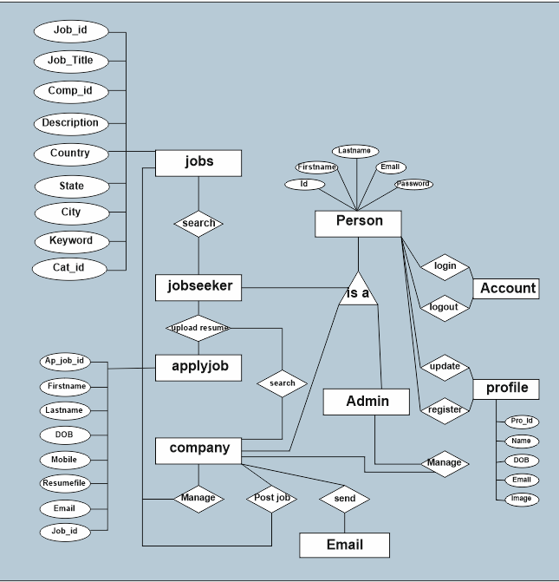

**3.2 Sytem Flowchart**

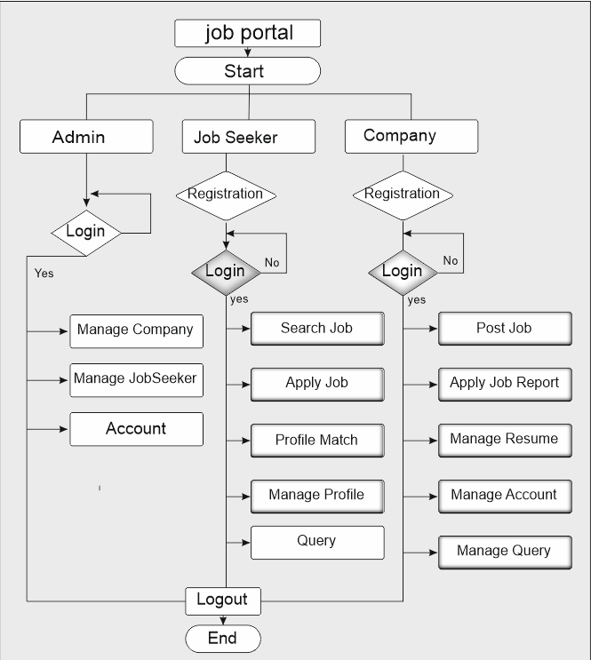

**3.3 Data Flow Diagram**

**Level-0** :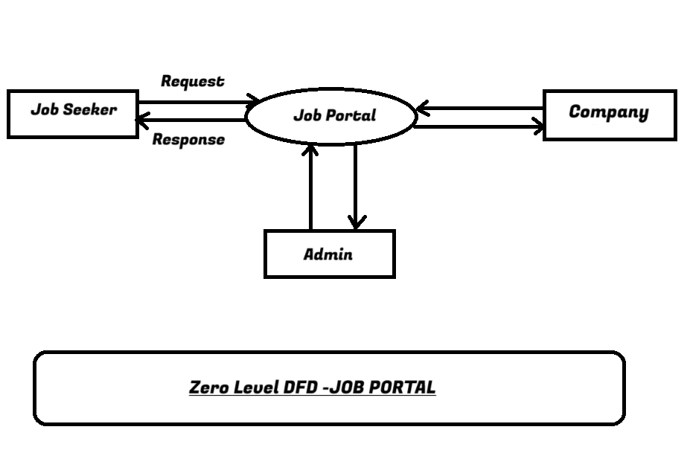

**Level-1 :**

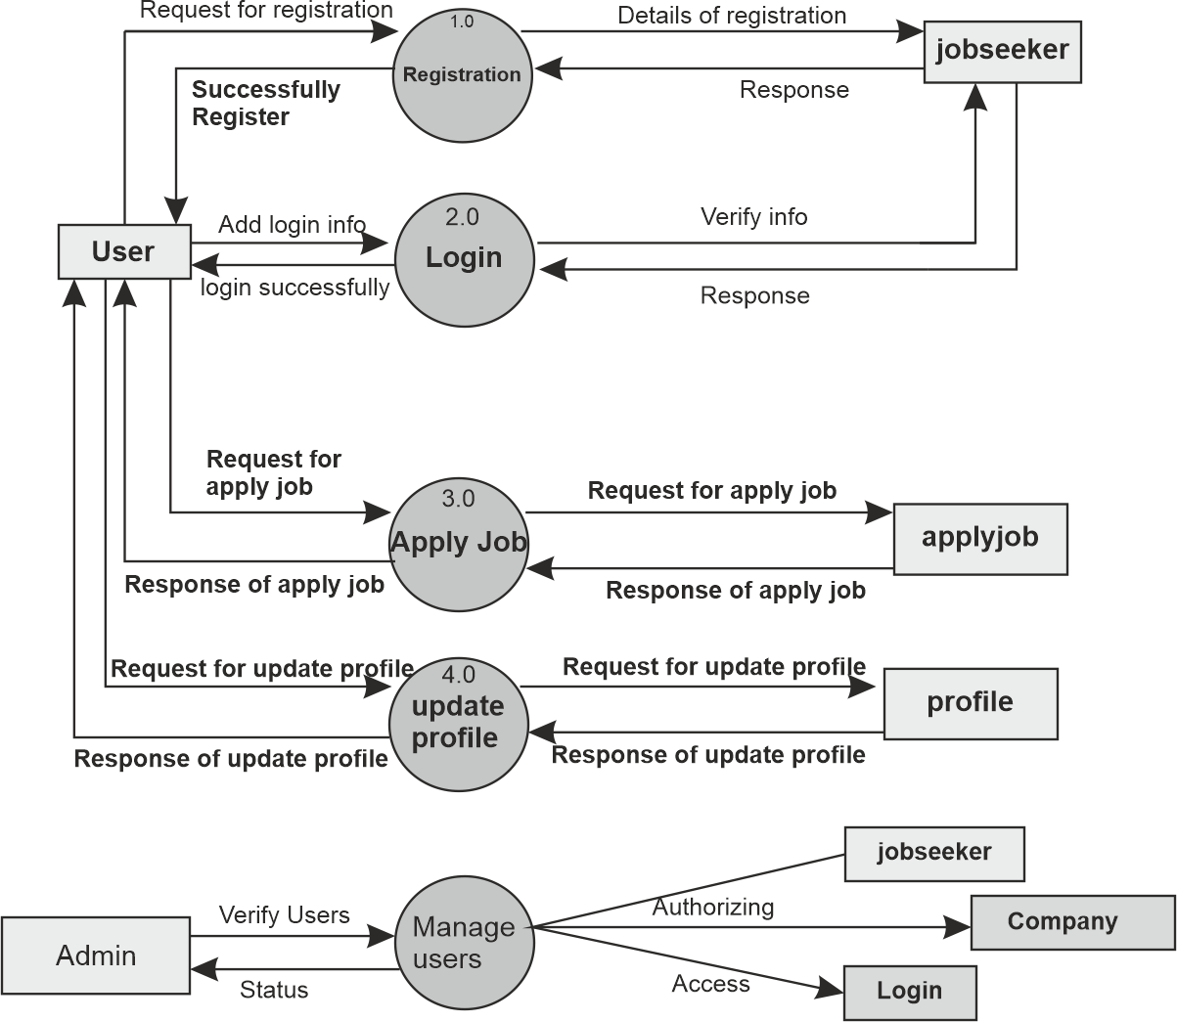

**3.3 Data Tables**

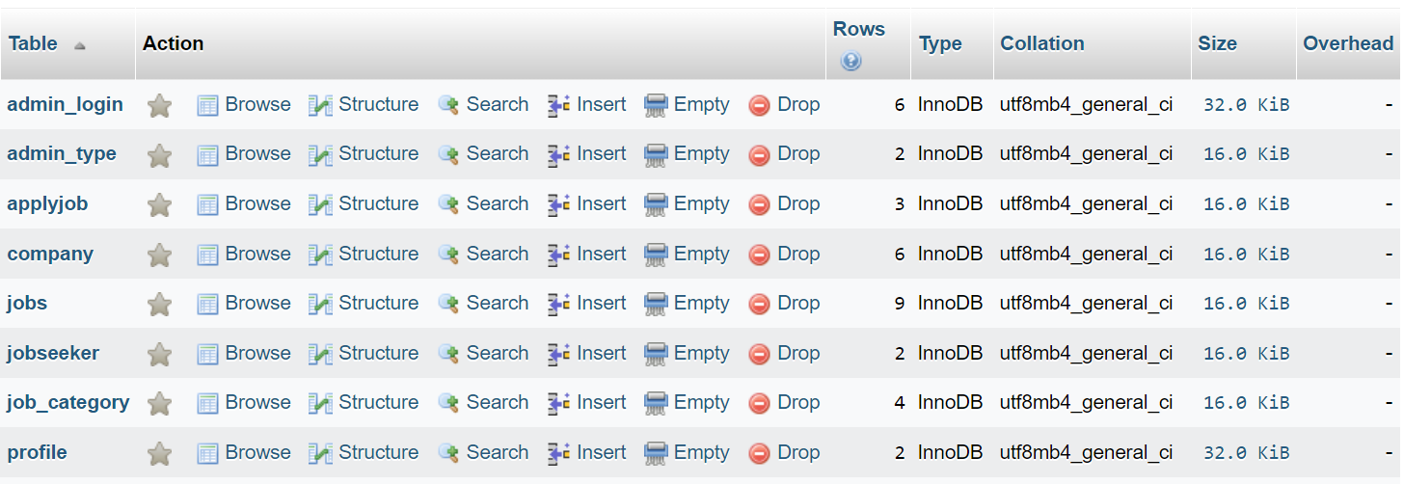

**Table 1 : admin_login**

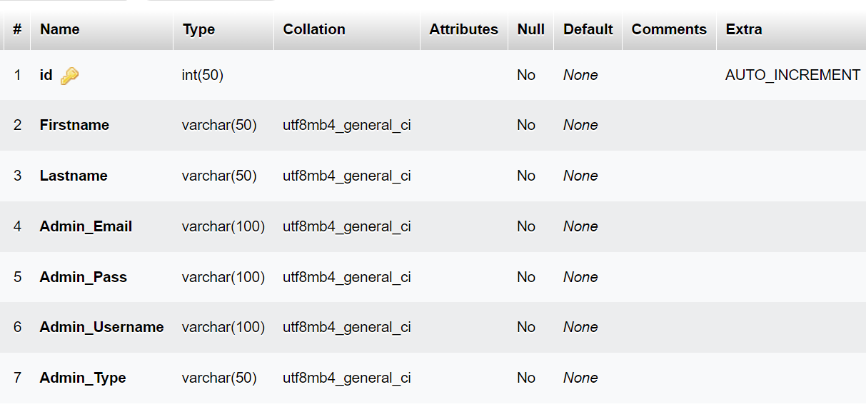

**Table 2 : admin_type**

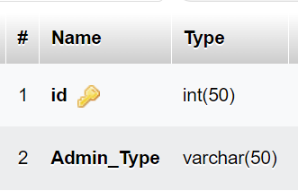

**Table 3 : applyjob**

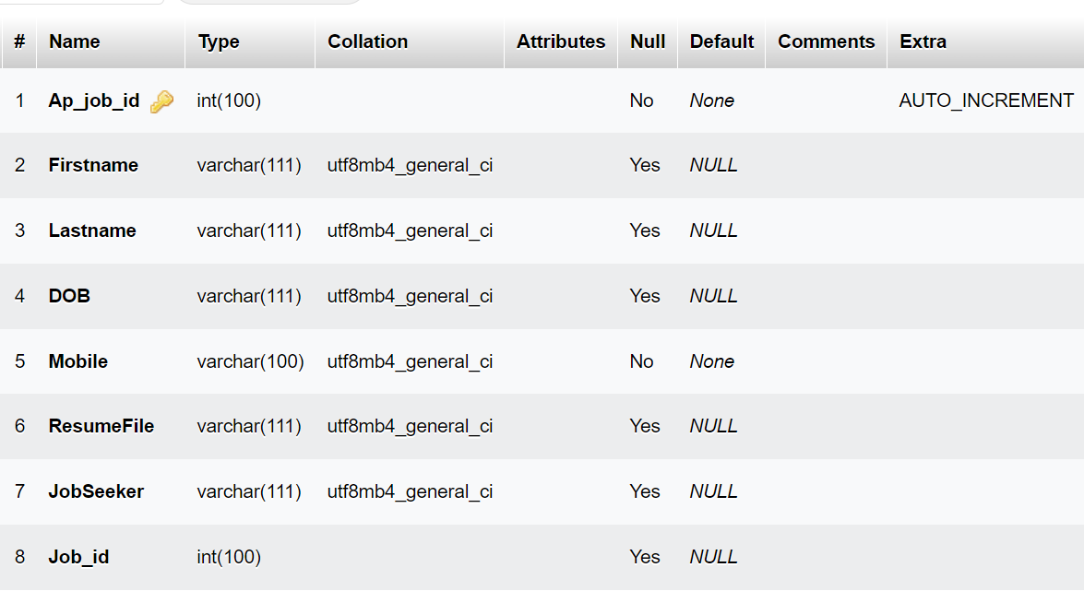

**Table 4 : Company**

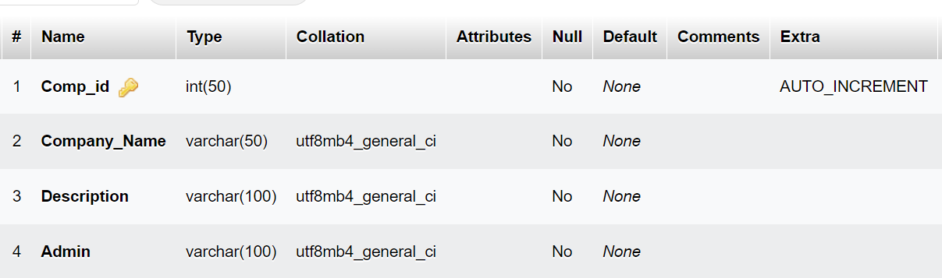

**Table 5 : jobs**

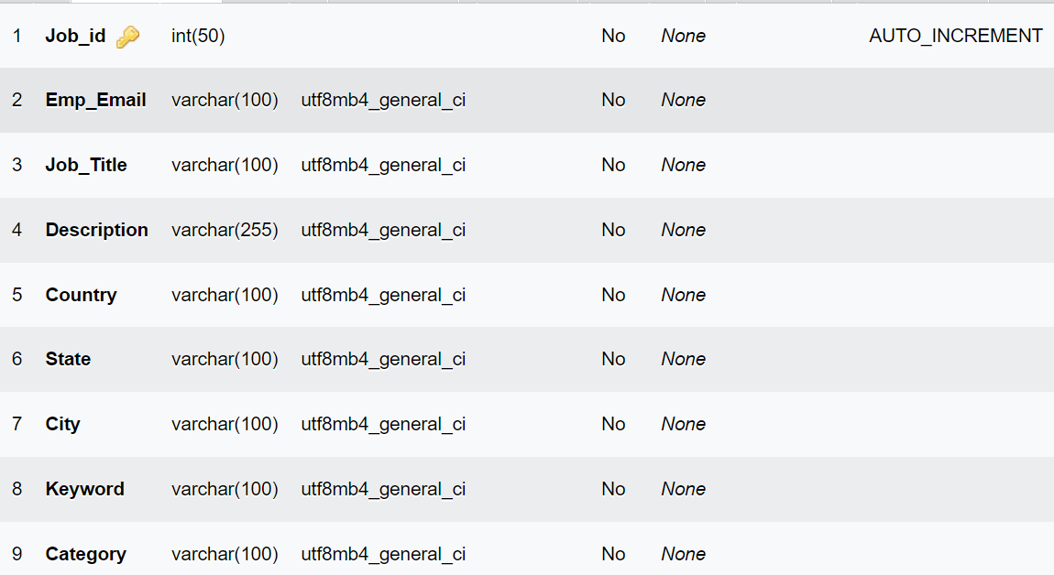

**Table 6 : jobseeker**

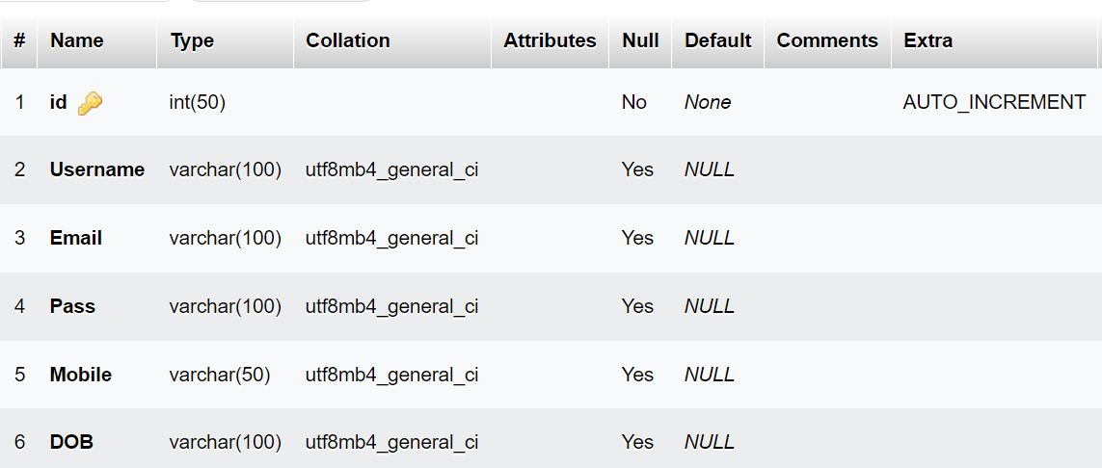

**Table 7 : job_category**

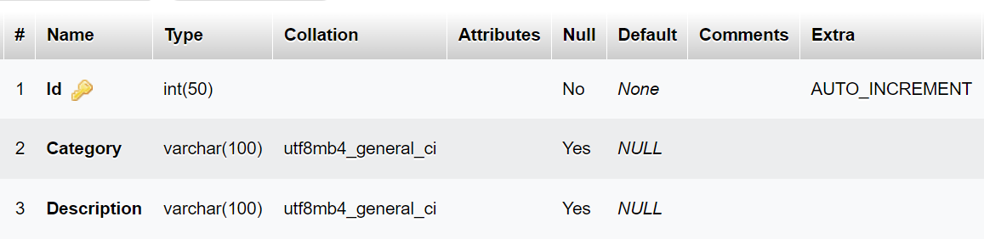

**Table 8 : profile**

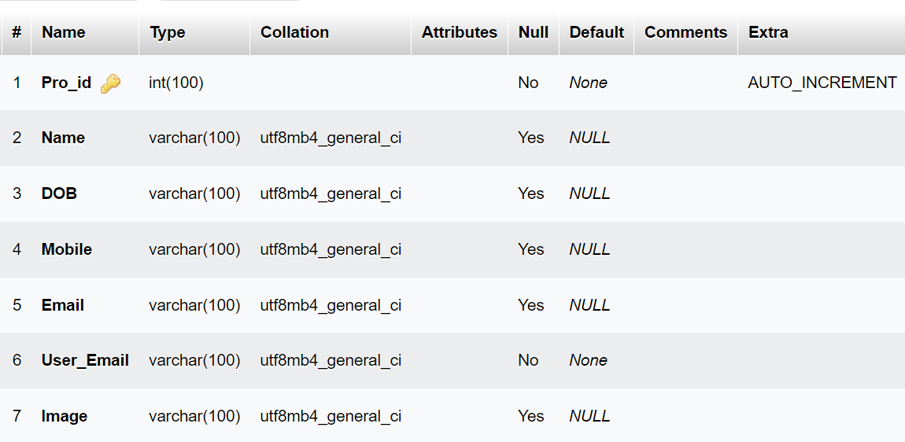

**Table 9 : contact**

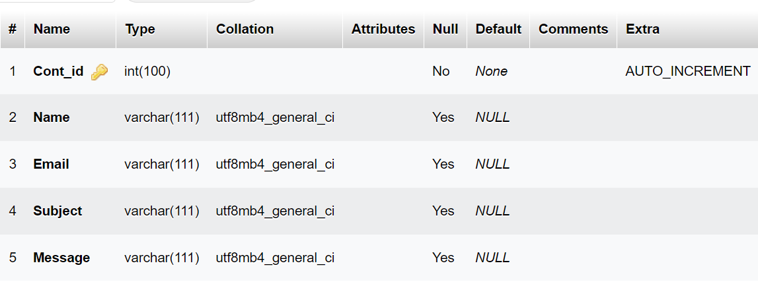

**4. SCREENSHOTS**

**1.JobSeeker Side**

**- Home Page**



This page is Job Seeker side Home Page.

**- About us Page**

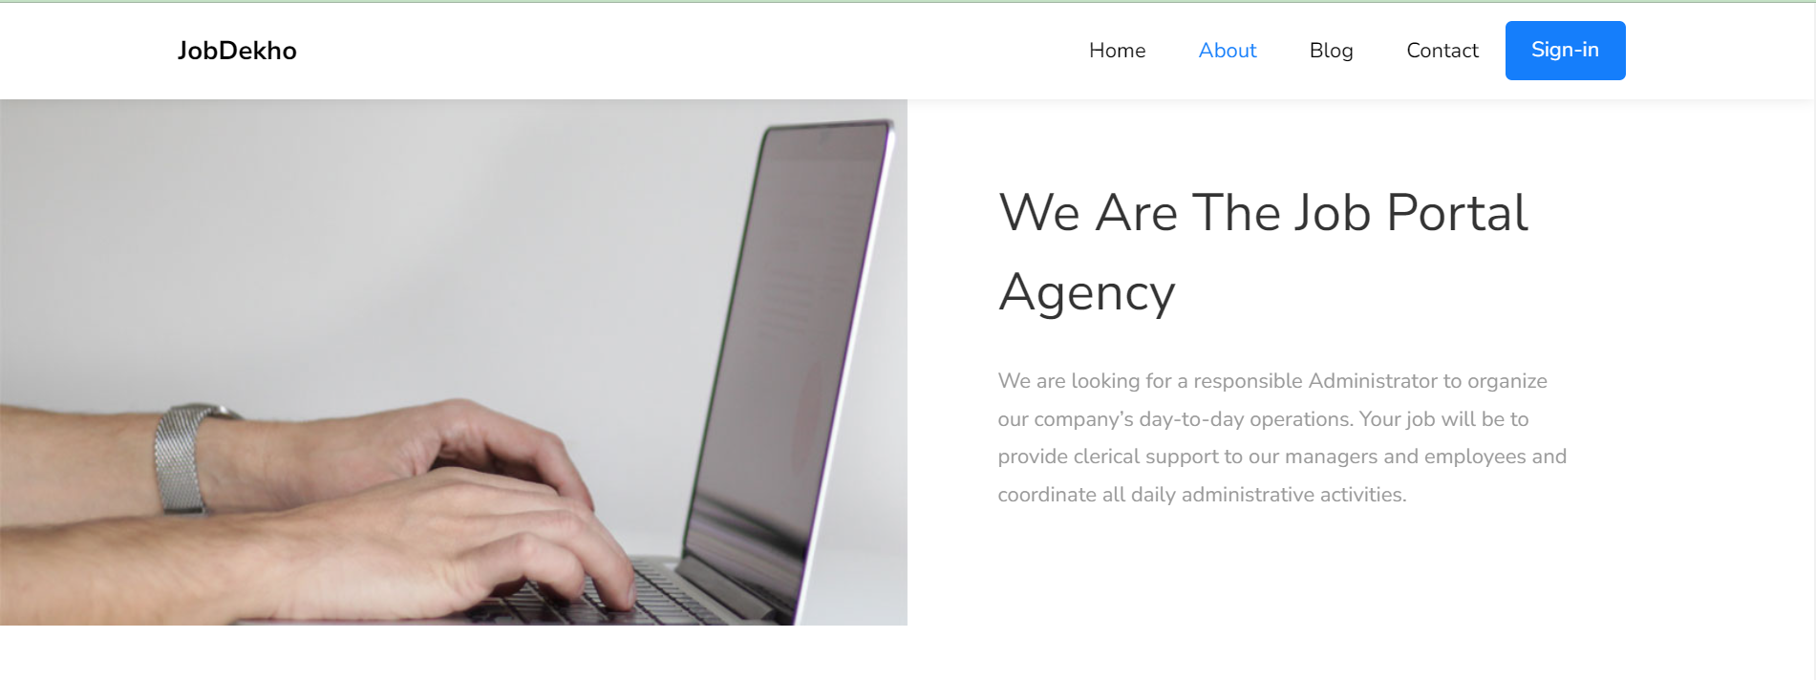

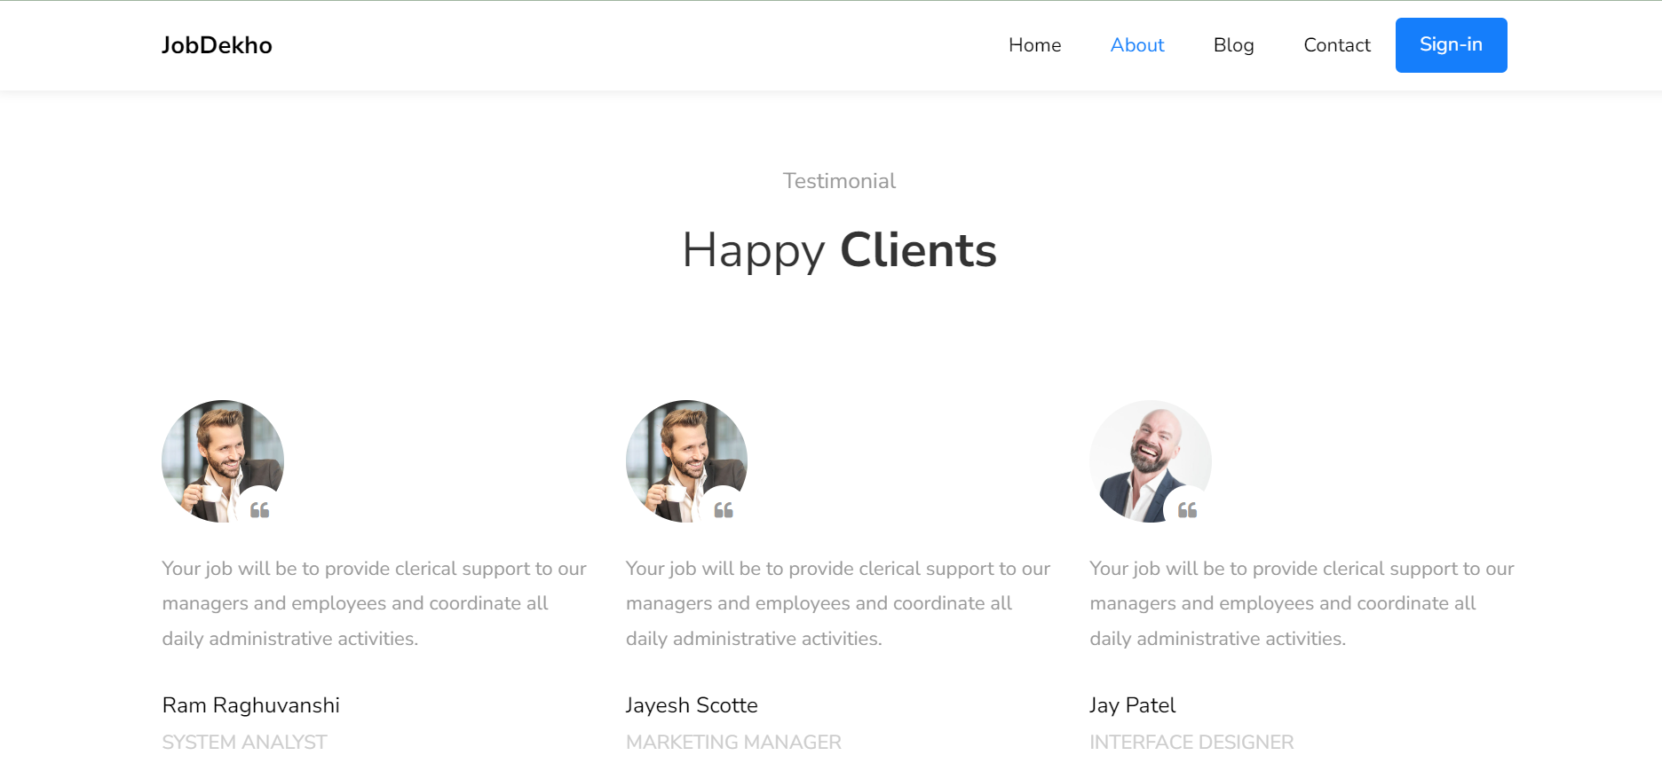

This page is Job Seeker side About us Page.

* **Blog Page**

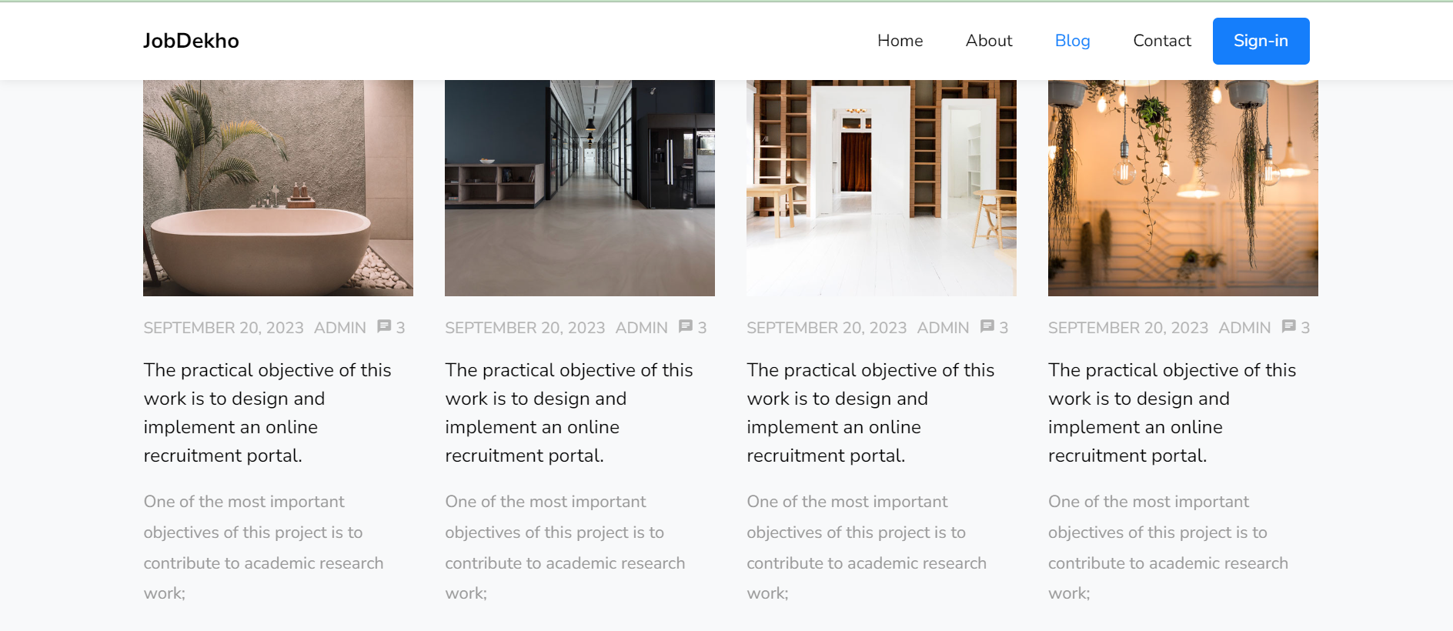



This page is Job Seeker side Blog Page.

* **Contact us Page**

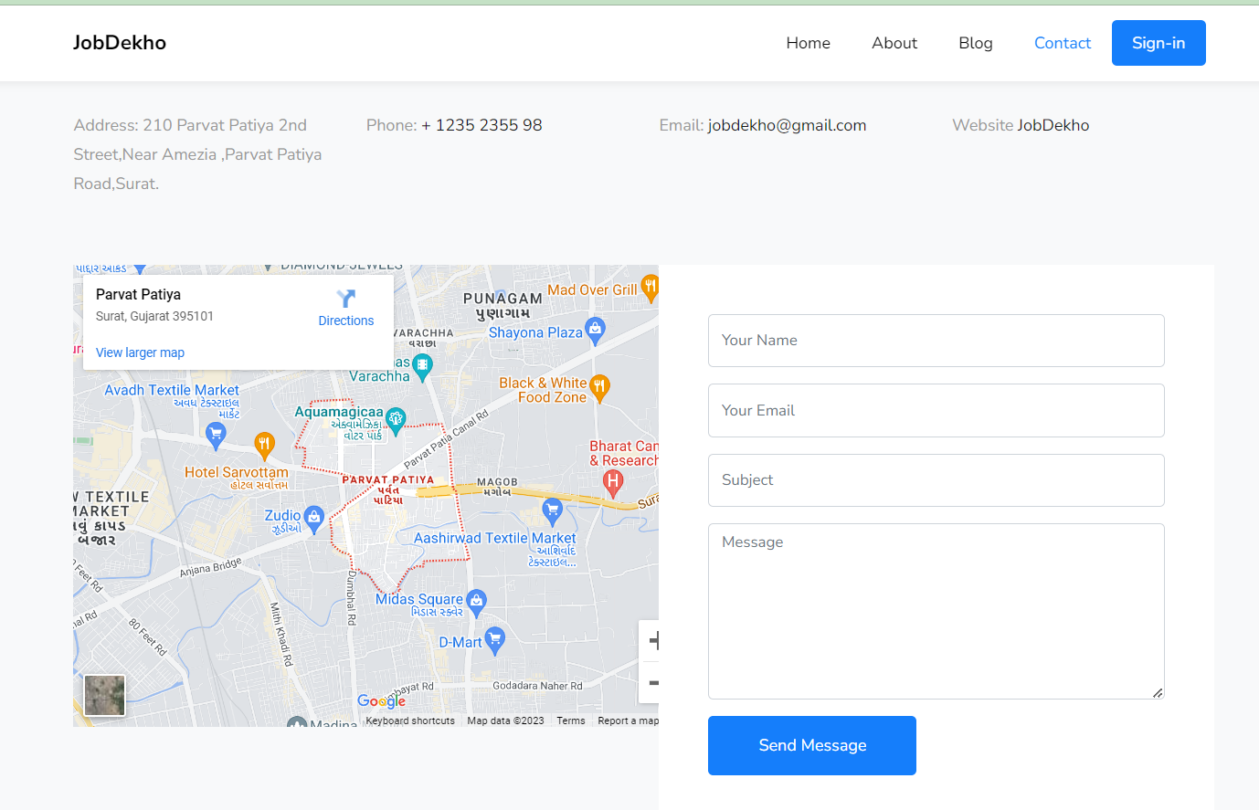

This page is Job Seeker side Contact us Page.

* **Sign Up Page**

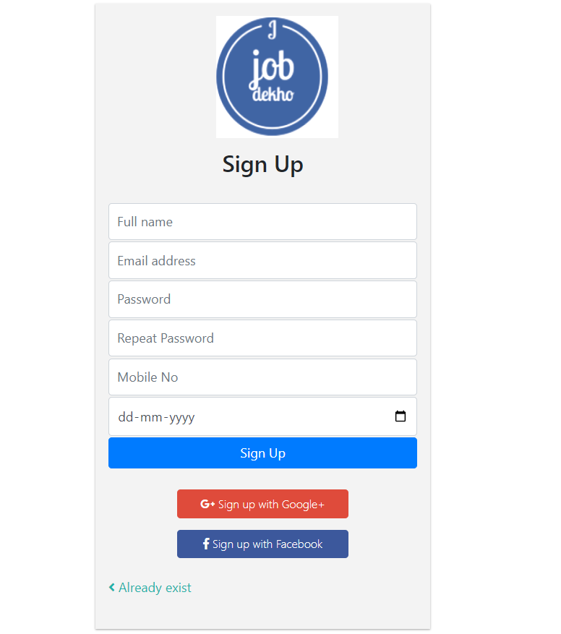

This page is Job Seeker side Sign-Up Page.

* **Sign in Page**

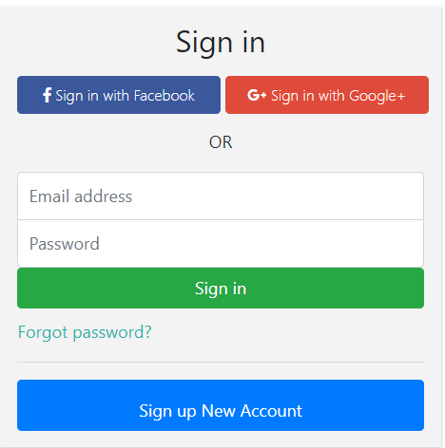

* **Recent Job Page**

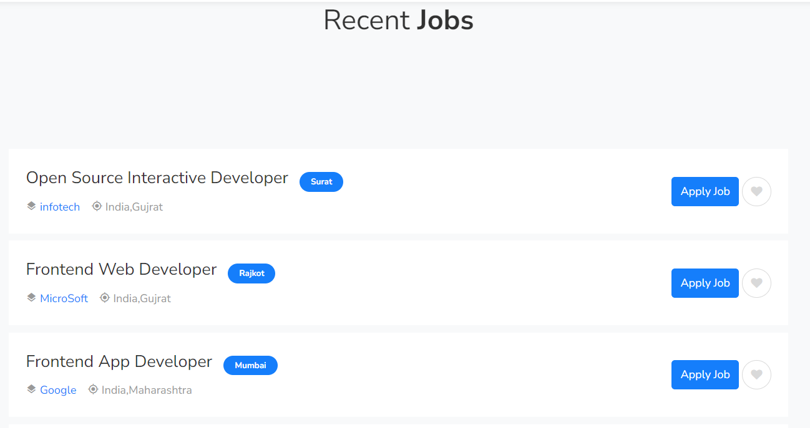

* **My Profile Page**

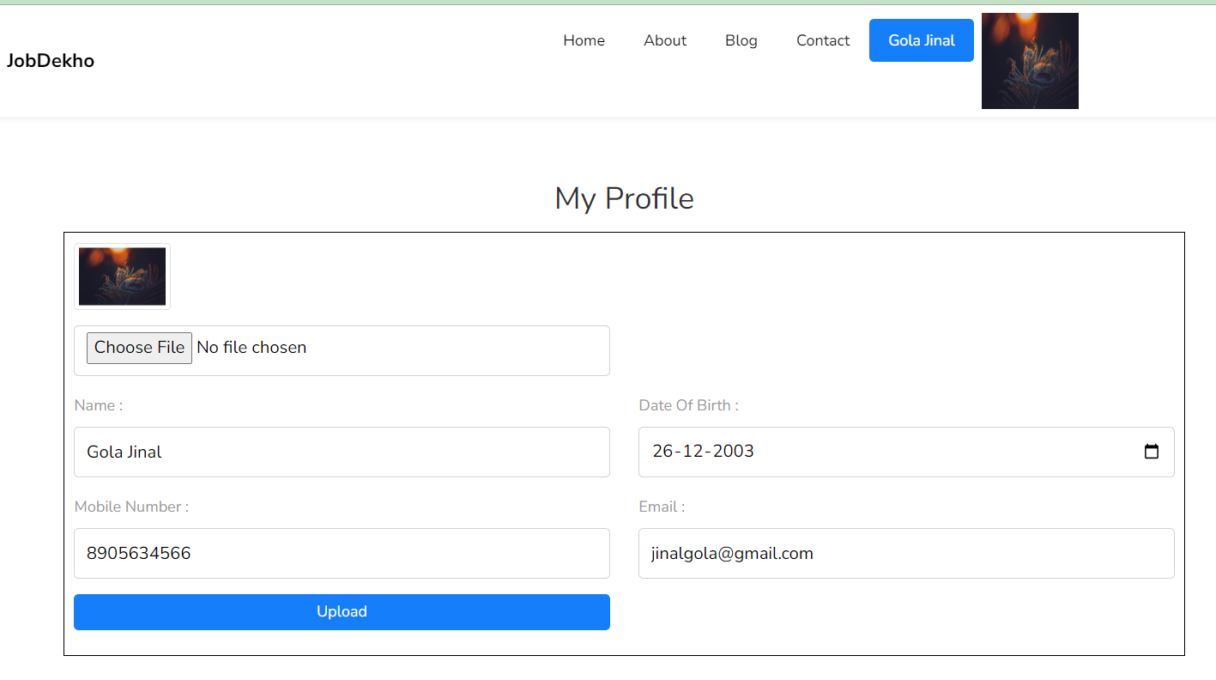

* **Add Resume Form Page**

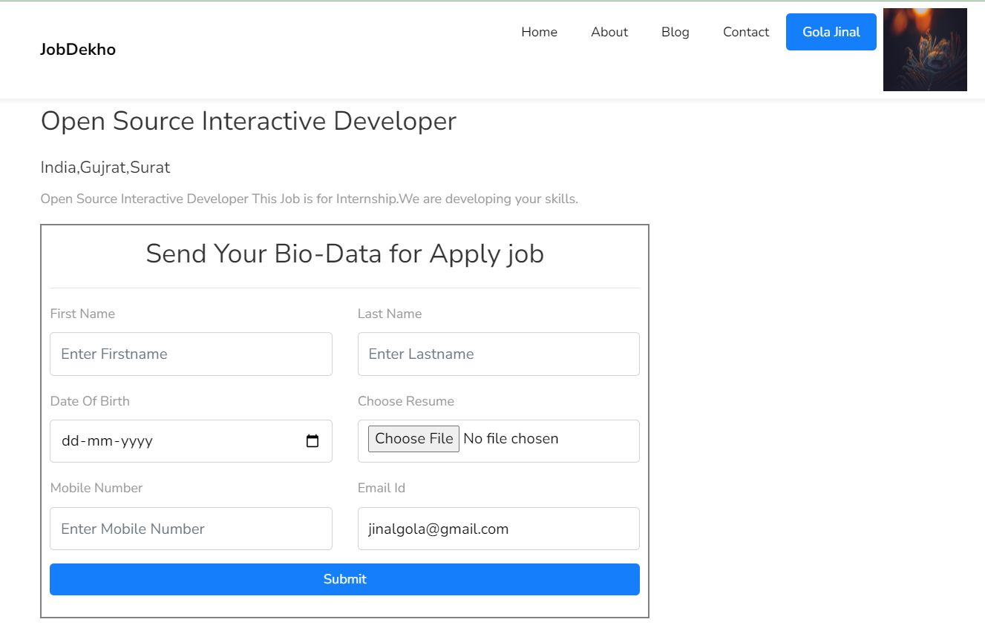

**2.Admin Side**

**- Login Page**

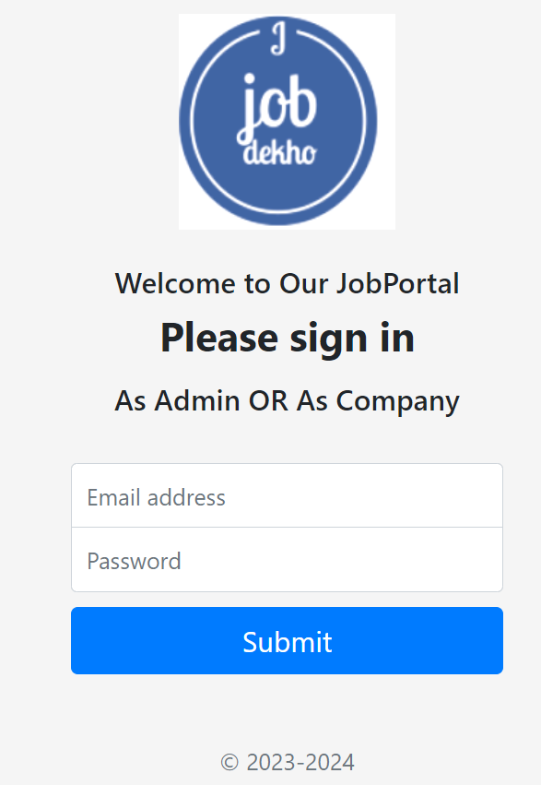

* **Dashboard Panel**

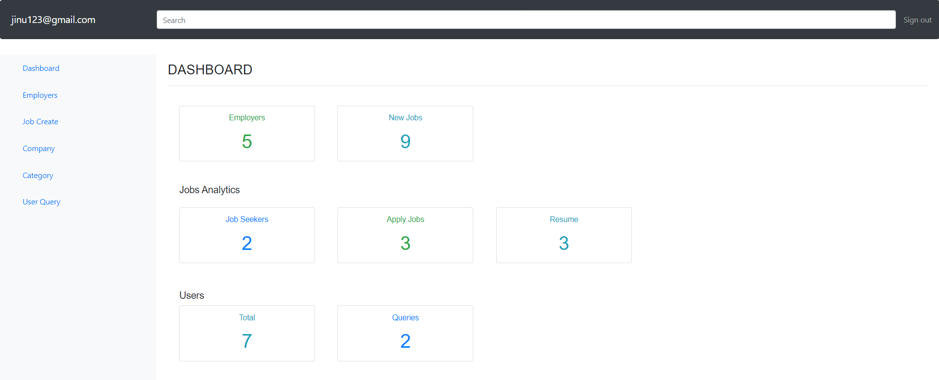

**5. REFERENCES**

* + [**https://www.w3schools.com**](https://www.w3schools.com/) **(For Common Query)**
  + [**https://www.fontawesome.com**](https://www.fontawesome.com/) **(For Icons)**
  + [**https://jquery.com**](https://jquery.com/) **(For jQuery)**
  + [**https://www.naukari.com**](https://www.naukari.com/) **(For View Demo)**
  + [**https://getbootstrap.com/docs/5.0/components**](https://getbootstrap.com/docs/5.0/components) **( For Code)**
  + [**https://www.youtube.com/playlist?list=PLEtkoO2np9syrpHVx2jIIvP5HtiWHrfvW**](https://www.youtube.com/playlist?list=PLEtkoO2np9syrpHVx2jIIvP5HtiWHrfvW) **(For Code)**